
ANSWER SHEET

Student’s Name: William Fan
M# 21210288

Questions:
- Was the traffic in the packet capture file captured in managed or monitor mode? Explain your answer. [1 point]:
Answer:
Monitor mode. Because in the WireShark, I can see multiple SSIDs, BSSIDs. It means that I can see details in all APs.

- Which company manufactured the access point used by “Starbucks WiFi”? [1 point]:
Answer:
Cisco Meraki.

- Is it possible to determine the manufacturer of the access point(s) used by the “Potomac RF Gun” WLAN? Provide proof to justify your answer. [1 point]:
Answer:
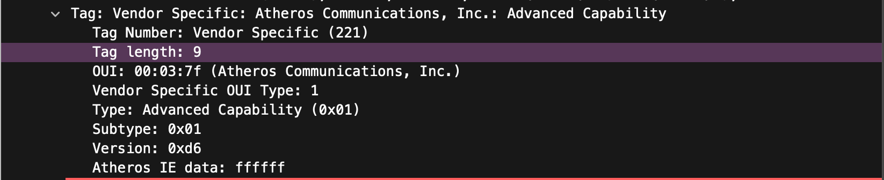
Yes it’s possible, after you apply filter wlan.ssid == “Potomac RF Gun”, locate the beacon frame and check the vendor, I could find the manufacturer of the AP used by “Potomac RF Gun” is called Athero Communications (Qualcomms)

- Is there more than one MAC address associated with the Potomac RF Gun WLAN? If so, list a few. [1 point]:
Answer:
02:ec:da:32:a7:d8
02:ec:da:38:1c:87
68:00:20:30:23:65
ff:0e:9b:87:ad:f9

- Does the packet capture contain any traffic from a Ubiquiti access point? If so, what is the destination address of the packet(s) generated by this AP? [1 point]:
Answer:
Broadcast,
22:89:03:d9:38:c7
b6:16:a6:3a:9b:9b
b6:dc:ac:05:40:d3
ba:d4:b7:13:5b:a9

- What kind of hardware device and what is the manufacturer of the device that most likely generated packet #9117?
Answer:
A Mobile device, and manufacturer is Motorola.

- What kind of wireless frame is packet #11620? What is its purpose? [1 point]:
Answer:
It’s a beacon frame, the purpose is to broadcast network info, synchronize time, contain information such as said, channel and encryption protocols.

- Do the SSIDs in the packet capture provide any clues to the physical location where the packet capture was performed? If so, in which Maryland down was the capture performed? [1 point]:
Answer:
Yes, and the city is Potomac.

- Is there evidence of interference in the packet capture? Explain your answer. [1 point]:
Answer:
Interference happens when wlan.fc.retry == 1, there were many entries when that was the filter.
I would attempt for another answer, there would be interference if signal strength < Noise, which I have seen some.
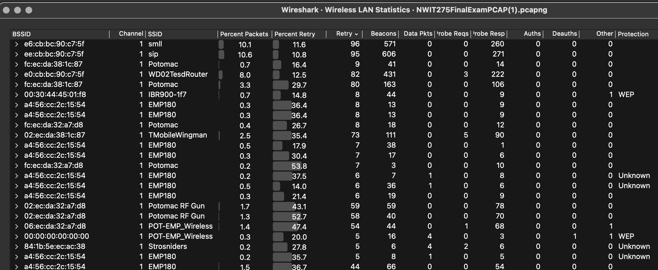
In the statistic graph, if it shows “retry”, it would possibly be an interference, which I have seen some.

- Which two channels is “Starbucks WiFi” using? [1 point]:
Answer: channel 157 and 1

- What is the most commonly used channel in the packet capture? [1 point]:
Answer:
channel 1 is the most used channel.

- Which frequencies are used by the WLANs in the packet capture? [1 point]:
Answer:
1. 2412MHz
2. 5785MHz

- What are the highest and lowest data rates of the WLANs in the packet capture? [1 point]:
Answer:
largest data rate: 72.222
Lowest data rate: 1

- Which protocol is displayed in the “Protocol” column of the packet capture? [1 point]:
Answer: 802.11. This is a wireless capture.

- What kind of wireless management frame is packet #1912? Explain the purpose of this frame. [1 point]:
Answer:
Type/Subtype: Probe Request (0x0004). The purpose of this frame is to allow a wireless client to scan for available networks.

- Which wireless management frame would be the response to packet #1912? [1 point]:
Answer:
The response to the packet would be probe response frame. Because frame 1912 is a probe request frame(management frame). They usually come in pairs.

- What kind of wireless management frame that is displayed below? Explain the purpose of this frame. [1 point]:
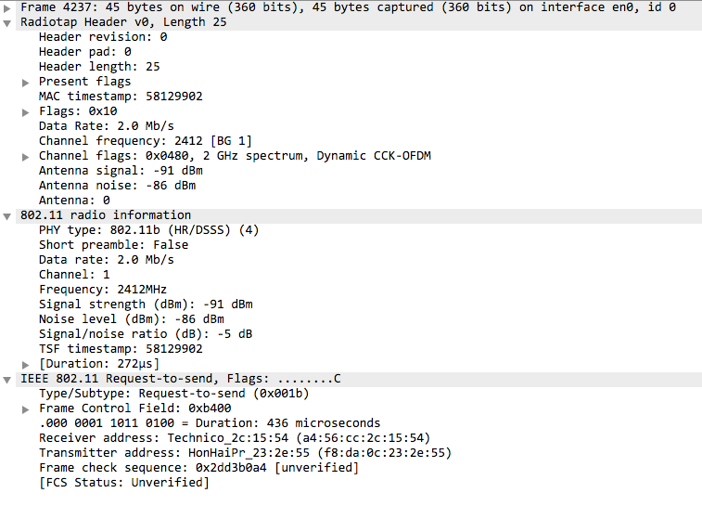

Answer:

This is a request to send frame. The purpose of this frame is to request permission to send a data frame.

- What kind of wireless management frame that is displayed below? Explain the purpose of this frame. [1 point]:
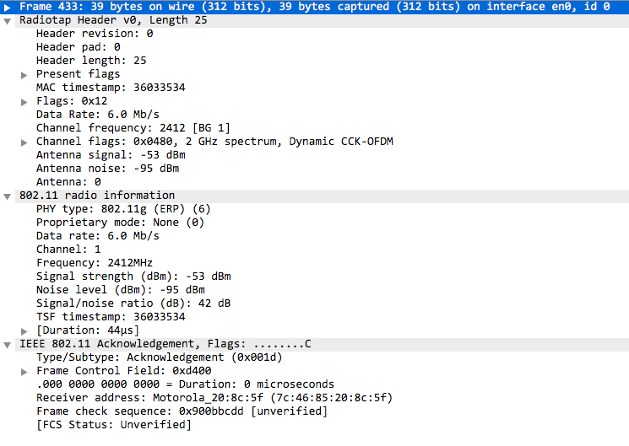

Answer:
This is control frame because Type is acknowledgement and it’s 39 bytes. It is to confirm the data is successfully received.

- What is the SSID of the wireless management frame displayed below? [1 point]:

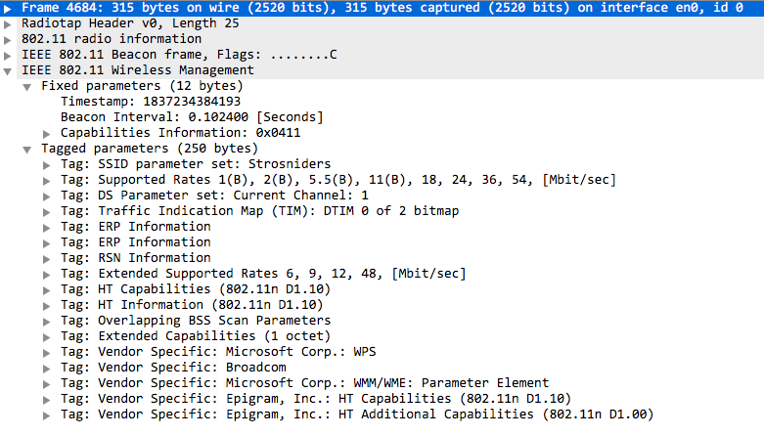

Answer:
Strosniders

- One free point. Enjoy the break!
Thank you Professor.

Done!

